Ex. No. 2 | WORKING WITH HTML5 FORM AND MEDIA ELEMENTS
Date of Exercise | 21.07.2026
GitHub Host Link | https://github.com/adhishm-0/web-technology-lab/tree/3a8dfd2ebc63367acb442f8c1106176f4411b495/exp2

Aim

To design and develop an Astrology & Horoscope Website using HTML5 by implementing various
HTML5 elements such as headings, tables, images, hyperlinks, audio, video, forms, fieldsets, progress bar, embedded documents, iframe, and other multimedia elements to create an interactive and user-friendly platform for exploring zodiac signs, daily horoscopes, astrological predictions, and birth chart information.

Description

This experiment is implemented using HTML5 to design a simple Astrology & Horoscope Website. The
webpage provides information about zodiac signs, daily horoscope predictions, astrological services, and an
interactive horoscope registration form. The following HTML5 elements are used:
- <!DOCTYPE html> Declares the document as an HTML5 document.
- <html> Root element that contains the entire webpage.
- <head> Contains the title and metadata of the webpage.
- <title> Displays the webpage title in the browser tab.
- <body> Contains all the visible contents of the webpage.
- <table> Organizes the webpage into different sections and aligns the contents.
- <tr> Creates rows in the table.
- <td> Creates table cells.
- <img> Displays the Astrology & Horoscope Website logo and zodiac images.
- <h1> Displays the main heading of the webpage.
- <h2> Displays section headings.
- <h3> Displays sub-headings.
- <p> Displays descriptive text about astrology and horoscope services.
- <a> Creates navigation hyperlinks such as Home, Zodiac Signs, Daily Horoscope, Compatibility, Birth Chart, and Contact.
- <audio> Plays relaxing meditation music or astrology-related audio.
- <video> Displays astrology or horoscope-related videos.
- <iframe> Embeds a YouTube astrology or horoscope video.
- <embed> Displays an astrology guide or zodiac PDF file.
- <form> Creates the horoscope registration form.
- <fieldset> Groups related form controls.
- <legend> Displays the title of each fieldset.
- <label> Displays labels for form fields.
- <input> Accepts user information such as name, date of birth, birth time, birth place, email, and password.
- <select> Creates a drop-down list for selecting the zodiac sign.
- <option> Defines the options inside the drop-down list.
- <progress> Displays horoscope profile completion or astrology learning progress.
- <br> Inserts line breaks between elements.
1
Ex. 2 | WORKING WITH HTML5 FORM AND MEDIA ELEMENTS

- <!-- --> Adds HTML comments for better readability of the source code.

Procedure:
1.Open Visual Studio Code or any HTML editor.
2.Create a folder named Kids Learning Website and create an index.html file.
3.Add the basic HTML5 structure using <!DOCTYPE html>, <html>, <head>, <title>, and <body>. 4.Design the webpage using tables, headings, images, and navigation links.
5.Add learning topics, educational video, audio, progress bar, and student registration form.
6.Embed the worksheet PDF using the <embed> tag.
7.Add the contact details at the bottom of the webpage.
8.Save the file and run it in a web browser or Live Server.
9.Verify that all HTML elements and multimedia contents are displayed correctly

Program

<!DOCTYPE html>

<html lang="en">

<head>

<meta charset="UTF-8">

<meta name="viewport" content="width=device-width, initial-scale=1.0">

<title>StarVerse - Astrology & Horoscope</title>

<link rel="stylesheet" href="style.css">

<meta name="description" content="StarVerse offers astrology, zodiac insights, birth charts, horoscopes, numerology and cosmic events with a premium mystical experience.">

</head>

<body>

<!-- Loading screen -->

<div class="loading-screen" id="loadingScreen">

<div class="loader-ring"></div>

</div>

<header class="topbar">

<div class="brand">

<img src="https://images.unsplash.com/photo-1500530855697-b586d89ba3ee?auto=format&fit=crop&w=80&q=80" alt="StarVerse logo">

<div>

Ex. 2 | WORKING WITH HTML5 FORM AND MEDIA ELEMENTS
2

<h1>StarVerse</h1>

<p>Astrology & Horoscope</p>

</div>

</div>

<button class="theme-toggle" id="themeToggle" aria-label="Toggle dark mode">🌙</button>

</header>

<nav class="main-nav" id="navbar">

<a href="#home">Home</a>

<a href="#about">About Astrology</a>

<a href="#zodiac">Zodiac Signs</a>

<a href="#horoscope">Horoscope</a>

<a href="#birthchart">Birth Chart</a>

<a href="#planets">Planets</a>

<a href="#numerology">Numerology</a>

<a href="#gallery">Gallery</a>

<a href="#media">Media</a>

<a href="#contact">Contact</a>

</nav>

<main>

<section class="hero" id="home">

<div class="cosmic-overlay"></div>

<small>Welcome to the mystical universe</small>

<h2 class="typing-text" data-text="Discover Your Destiny Through the Stars"></h2>

<p>Explore premium astrology insights with modern birth charts, horoscope readings, planetary guidance and cosmic wellness.</p>

<div class="hero-actions">

Ex. 2 | WORKING WITH HTML5 FORM AND MEDIA ELEMENTS
3

<a href="#horoscope" class="btn btn-primary">Explore Horoscope</a>

<a href="#zodiac" class="btn btn-secondary">Know Your Zodiac</a>

</div>

<div class="hero-metrics">

<article>

<h3><span id="currentDate">--</span></h3>

<p>Current date</p>

</article>

<article>

<h3><span id="currentTime">--</span></h3>

<p>Current time</p>

</article>

<article>

<h3><span id="visitorCounter">0</span>+</h3>

<p>Cosmic visitors today</p>

</article>

</div>

</div>

<div class="hero-visual">

<img src="https://images.unsplash.com/photo-1446776811953-b23d57bd21aa?auto=format&fit=crop&w=900&q=80" alt="Galaxy and moon illustration">

</div>

<div class="planet-orbit">

<span class="planet planet-sun"></span>

<span class="planet planet-moon"></span>

<span class="planet planet-venus"></span>

</div>

</section>

Ex. 2 | WORKING WITH HTML5 FORM AND MEDIA ELEMENTS
4

<div class="section-heading">

<small>About Astrology</small>

<h2>Why the stars matter for your destiny</h2>

<p>A modern guide to astrology that blends tradition, history, and performance wisdom for real life.</p>

</div>

<div class="info-grid">

<article>

<h3>What is Astrology?</h3>

<p><strong>Astrology</strong> is the study of planetary and star alignments that influence personality, timing, and emotional patterns.</p>

</article>

<article>

<h3>History</h3>

<p>From ancient Mesopotamia to modern digital horoscopes, astrology has evolved across cultures and centuries.</p>

</article>

<article>

<h3>Western Astrology</h3>

<p>Western astrology is based on sun signs, houses, and planetary transits to paint your personality map.</p>

</article>

<article>

<h3>Vedic Astrology</h3>

</article>

<article>

<h3>Chinese Astrology</h3>

</article>

Ex. 2 | WORKING WITH HTML5 FORM AND MEDIA ELEMENTS
5

<article>

<h3>Benefits</h3>

<ol>

<li>Self-awareness</li>

<li>Better timing</li>

<li>Relationship insight</li>

<li>Career guidance</li>

</ol>

</article>

</div>

<figure class="about-figure">

<img src="https://images.unsplash.com/photo-1500375592092-40eb2168fd21?auto=format&fit=crop&w=900&q=80" alt="Astrology wheel illustration">

<figcaption>Discover the harmony of star maps, planets, and zodiac energy.</figcaption>

</figure>

<aside>

<blockquote>

"The stars impel, they do not compel." <strong>— William Shakespeare</strong>

</blockquote>

</aside>

<article class="myths">

<h3>Common Myths</h3>

<ul>

<li>Astrology is only about sun signs.</li>

<li>Horoscopes predict exact events.</li>

<li>It is incompatible with science.</li>

</ul>

</article>

Ex. 2 | WORKING WITH HTML5 FORM AND MEDIA ELEMENTS
6

</section>

<section class="section zodiac-section" id="zdiac">

<div class="section-heading">

<small>Zodiac Signs</small>

<h2>Meet all 12 signs of the zodiac</h2>

<p>Search a sign or browse the cosmic cards to learn about personality, love, career, and your lucky match.</p>

</div>

<div class="search-bar">

<label for="zodiacSearch">Live zodiac search</label>

<input type="search" id="zodiacSearch" placeholder="Search Aries, Taurus, Gemini...">

</div>

<div class="zodiac-grid" id="zodiacGrid">

<!-- Zodiac cards generated in HTML for JS filter -->

<article class="zodiac-card" data-name="Aries">

<img src="https://images.unsplash.com/photo-1517976487492-5750f3195933?auto=format&fit=crop&w=300&q=60" alt="Aries symbol">

<h3>Aries</h3>

<p><strong>Dates:</strong> Mar 21 - Apr 19</p>

<p><strong>Element:</strong> Fire</p>

<p><strong>Planet:</strong> Mars</p>

<p><strong>Lucky Color:</strong> Red</p>

<p><strong>Lucky Number:</strong> 9</p>

<p><strong>Compatible:</strong> Leo, Sagittarius</p>

<p><strong>Strengths:</strong> Bold, confident, passionate</p>

<p><strong>Weaknesses:</strong> Impulsive, impatient</p>

<p><strong>Career:</strong> Leadership, entrepreneurship</p>

<p><strong>Health:</strong> Energetic needs balance</p>

Ex. 2 | WORKING WITH HTML5 FORM AND MEDIA ELEMENTS
7

</article>

<article class="zodiac-card" data-name="Taurus">

<img src="https://images.unsplash.com/photo-1518544885055-4a0b3d9cd173?auto=format&fit=crop&w=300&q=60" alt="Taurus symbol">

<h3>Taurus</h3>

<p><strong>Dates:</strong> Apr 20 - May 20</p>

<p><strong>Element:</strong> Earth</p>

<p><strong>Planet:</strong> Venus</p>

<p><strong>Lucky Color:</strong> Green</p>

<p><strong>Lucky Number:</strong> 6</p>

<p><strong>Compatible:</strong> Virgo, Capricorn</p>

<p><strong>Strengths:</strong> Reliable, sensual, patient</p>

<p><strong>Weaknesses:</strong> Stubborn, possessive</p>

<p><strong>Love:</strong> Deep and steady</p>

<p><strong>Career:</strong> Finance, design, agriculture</p>

<p><strong>Health:</strong> Grounding nature supports wellness</p>

</article>

<article class="zodiac-card" data-name="Gemini">

<img src="https://images.unsplash.com/photo-1483721310020-03333e577078?auto=format&fit=crop&w=300&q=60" alt="Gemini symbol">

<h3>Gemini</h3>

<p><strong>Dates:</strong> May 21 - Jun 20</p>

<p><strong>Element:</strong> Air</p>

<p><strong>Planet:</strong> Mercury</p>

<p><strong>Lucky Color:</strong> Yellow</p>

<p><strong>Compatible:</strong> Libra, Aquarius</p>

<p><strong>Strengths:</strong> Curious, adaptable, clever</p>

<p><strong>Weaknesses:</strong> Restless, indecisive</p>

<p><strong>Love:</strong> Playful and communicative</p>

Ex. 2 | WORKING WITH HTML5 FORM AND MEDIA ELEMENTS
8

<p><strong>Career:</strong> Media, education, sales</p>

<p><strong>Health:</strong> Nervous energy needs mindful focus</p>

</article>

<article class="zodiac-card" data-name="Cancer">

<img src="https://images.unsplash.com/photo-1500534314209-a25ddb2bd429?auto=format&fit=crop&w=300&q=60" alt="Cancer symbol">

<h3>Cancer</h3>

<p><strong>Dates:</strong> Jun 21 - Jul 22</p>

<p><strong>Element:</strong> Water</p>

<p><strong>Planet:</strong> Moon</p>

<p><strong>Lucky Color:</strong> Silver</p>

<p><strong>Lucky Number:</strong> 2</p>

<p><strong>Compatible:</strong> Scorpio, Pisces</p>

<p><strong>Strengths:</strong> Compassionate, protective, intuitive</p>

<p><strong>Weaknesses:</strong> Moody, clingy</p>

<p><strong>Love:</strong> Deeply nurturing</p>

<p><strong>Career:</strong> Healing, hospitality, arts</p>

<p><strong>Health:</strong> Emotional care is vital</p>

</article>

<article class="zodiac-card" data-name="Leo">

<img src="https://images.unsplash.com/photo-1483721310020-03333e577078?auto=format&fit=crop&w=300&q=60" alt="Leo symbol">

<h3>Leo</h3>

<div class="footer-bottom">

<p>&copy; 2026 StarVerse. All rights reserved.</p>

<p>Designed with cosmic care.</p>

</div>

</footer>

<button class="back-to-top" id="backToTop" aria-label="Back to top">↑</button>

Ex. 2 | WORKING WITH HTML5 FORM AND MEDIA ELEMENTS
9

<script src="script.js"></script>

</body>

</html>

Output

screenshot:

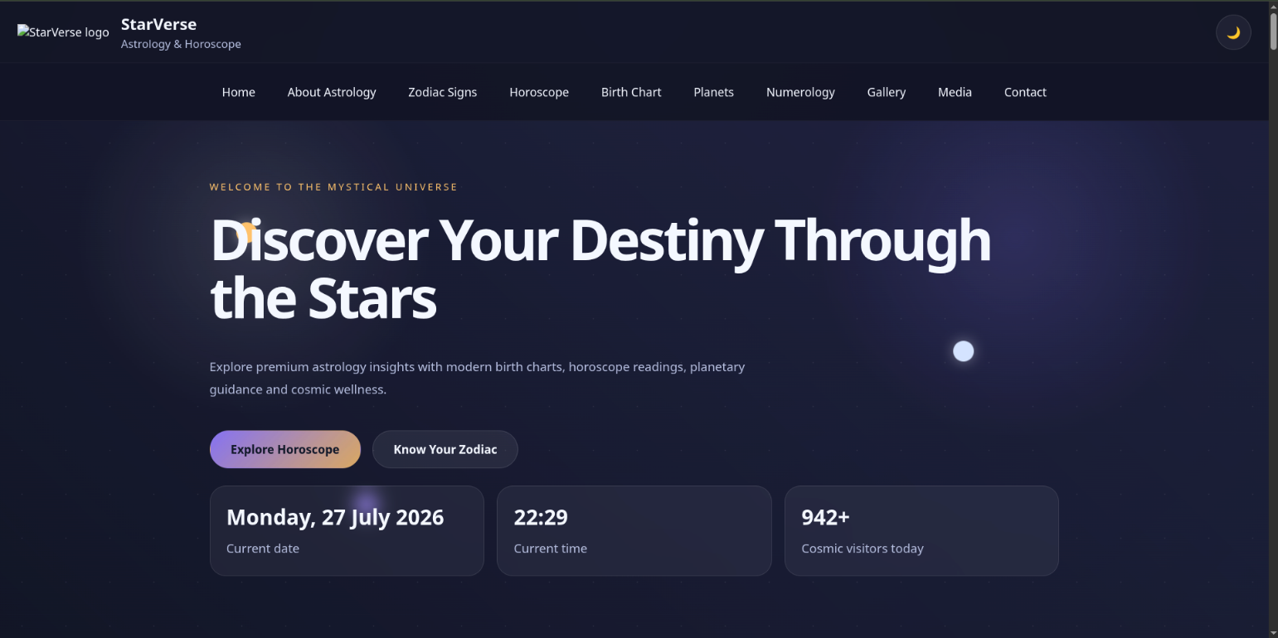

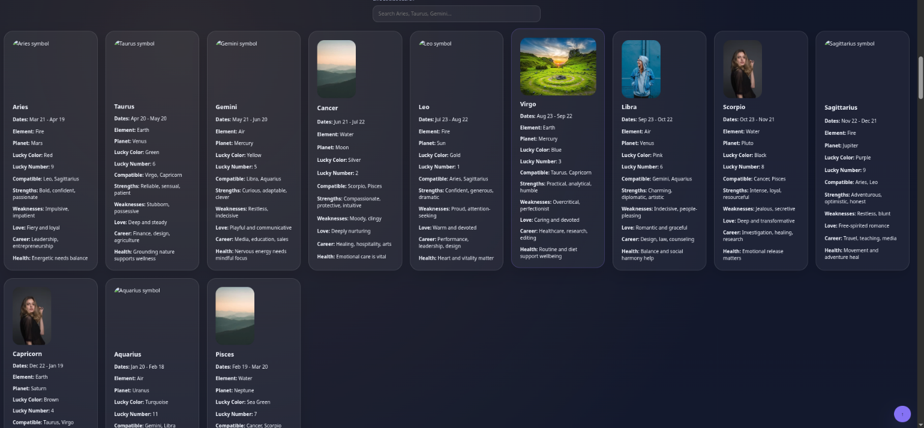

10
Ex. 2 | WORKING WITH HTML5 FORM AND MEDIA ELEMENTS

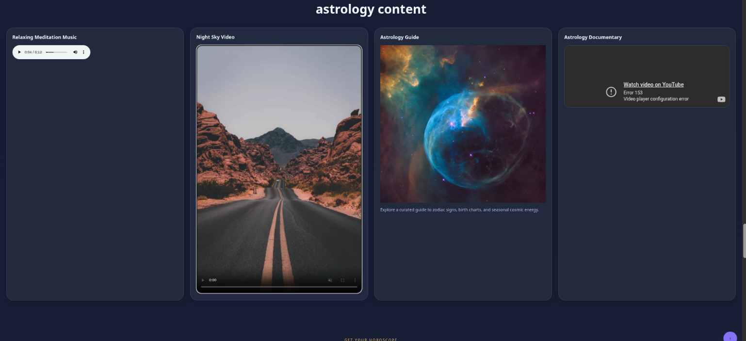

Result:

Thus, the Astrology & Horoscope Website was successfully developed using HTML5. The webpage effectively displayed astrology information, horoscope predictions, multimedia content, and an interactive registration form.

Ex. 2 | WORKING WITH HTML5 FORM AND MEDIA ELEMENTS
11

